The Winter Pack - Product Application Guide
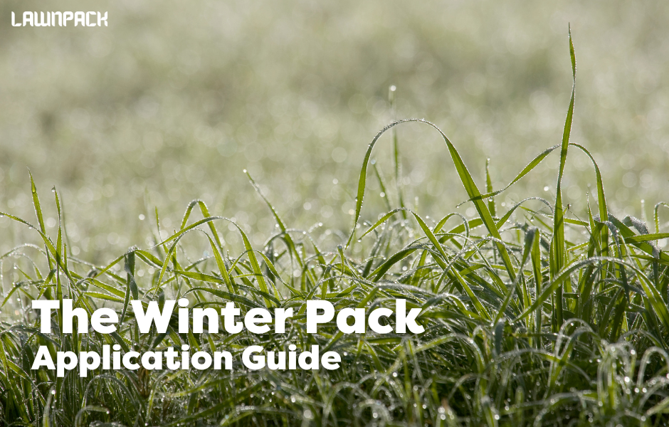
Protect and strengthen your lawn through the coldest months of the year. The Winter Protection Pack is designed to harden turf, support root health and improve resistance to disease and moss while grass growth naturally slows. It provides 12+ weeks of protection during winter when lawns are under the most stress.
Winter conditions limit growth, but disease pressure remains high due to cold, damp weather. This pack focuses on turf resilience rather than growth, helping your lawn come out of winter in the best possible condition. Best applied from December to February.
Winter Protection Fertiliser
Apply evenly across the lawn at 30g per SQM, ideally using a spreader for the most consistent coverage.
You can apply by hand (wearing gloves), but care must be taken to ensure even distribution, as uneven coverage may lead to patchy colour or growth.
Do not exceed the recommended application rates for your lawn size, as stated on the label.
For best results:
- Walk in straight lines from one end of the lawn to the other
- Apply in two passes if possible (one lengthways and one widthways) to ensure even coverage
This fertiliser is low in nitrogen and high in potassium to promote turf hardening, root strength and disease resistance through winter.
Biostimulant Booster
Follow up with 4-5ml of Biostimulant Booster diluted in 250ml of water per SQM evenly applied with a watering can with a fine rose head or a pressure sprayer. Mix thoroughly in your watering can or sprayer before applying.
The Biostimulant Booster can be mixed with Deeper Green Iron Sulphate for quicker application. If combining products, always follow the Iron Sulphate dilution rates.
Deeper Green Iron Sulphate
Apply evenly across the whole lawn using a watering can with a fine rose head or a sprayer.
The dosage depends on the condition of your lawn:
If your lawn has moss:
Apply at 5g per SQM.
After 7–14 days, rake out any blackened moss and dispose of it.
If your lawn does not have moss:
Apply at 2.5g per SQM to harden the turf, deepen green colour and improve disease resistance.
Each application method requires a different dilution rate. Please refer to the Iron Sulphate Guide for full dilution instructions.
Winter Lawn Maintenance
Maintaining your lawn during winter is about protection rather than growth.
- Mowing: Mow only when necessary and conditions allow. Raise the cutting height and avoid mowing during frost or when the ground is saturated.
- Leaves: Remove fallen leaves regularly to prevent smothering, disease and yellowing of the grass underneath.
- Traffic: Try to limit foot traffic on the lawn during frosty or waterlogged conditions to avoid compaction and damage.
- Weeds: Selective weed control should be avoided during winter, as weeds are not actively growing.
What’s Up Next?
As temperatures rise and growth resumes in spring, your next steps depend on the condition of your lawn:
- If your lawn is healthy and established:
Apply the Spring Pack to encourage strong growth, colour and recovery after winter.
- If your lawn is thin, damaged or requires overseeding:
Use The Lawn Pack Renovation Kit, which includes seed, fertiliser and biostimulant to help repair bare patches and improve density before moving into spring feeding.

Applied correctly, the Winter Pack ensures your lawn enters spring stronger, healthier and ready for the growing season ahead.

